Homework 7: 100 Points
This Homework contains examples of multiprocessors and cache coherency.
Please submit your answers in a document and upload it in Canvas by the due date.
Present your work neat, clear, organized, logical, and make your case; don’t leave it to our interpretation of your answer. There is 10% penalty per day for delay in submitting the homework.
- (25 Points) Using the architecture and data of Chapter 5, Example 5, write the result of the following actions using the method of Example 5. Note that as in Example 5, all these operations are independent of each other and performed on the original state of Memory and Cache.
- P0: read 120
P0.B0: S, 120, 00 10 (Shared in P0)

- P0: write 120 ← 80
P0.B0: M, 120, 00 80
P1.B0: I, 120, 00 20 (invalidated)

- P3: write 120 ← 80
P0.B0: M, 120, 00 80
P3.B0: M, 120, 00 80

- P1: read 110
P1.B1: S, 110, 00 30

- P0: write 105 ←48
P0.B1: M, 105, 00 48
P1.B1: I, 105, 00 08
P3.B1: I, 105, 00 08

- P0: write 130 ← 78
P0.B2: M, 130, 00 78
P1.B2: I, 130, 00 23
P3.B2: I, 130, 00 23

- P3: write 130 ← 78
P0.B2: I, 130, 00 78
P3.B2: M, 130, 00 78
- (25 Points) Consider a dual core (A and B) with
  - Snooping Protocol
  - Write Invalidate
  - Write through
  - Variable x in memory with content 7
Show the activities and cache and memory content as:
- Core B reads x
Core B reads the value of x from memory.
Memory: x=7
Core A Cache: x=7
Core B Cache: x=7

- Core A reads x
Core A reads the value of x. Since Core B has a valid copy, Core A fetches from Core B's cache.
Memory: x=7
Core A Cache: x=7
Core B Cache: x=7

- Core B writes 2 to x
Core B writes 2 to x, which triggers a write-through, so memory is updated with x=2.

The write-invalidate protocol invalidates Core A's cache, as Core B now holds the exclusive write to x.
Memory: x=2
Core A Cache: Invalid
Core B Cache: x=2

- Core A reads x
Core A reads x, but since its cache is invalid, it must fetch the value from memory.
Memory: x=2
Core A Cache: x=2
Core B Cache: x=2

- Core B writes 5 to x
Core B writes 5 to x, which again triggers a write-through, and memory is updated with x=5. The write-invalidate protocol invalidates Core A's cache once again.
Memory: x=5
Core A Cache: Invalid
Core B Cache: x=5

- (25 Points) Consider a dual core (A and B) with
  - Snooping Protocol
  - Write Update
  - Write Back
  - Variable x in memory with content 8
Show the activities and cache and memory content as:
- Core A reads x
Core A reads x, which is currently 8 in memory.
Memory: x=8
Core A Cache: x=8 (After reading from memory)
Core B Cache: x=8

- Core B reads x
Core B also reads x, which is still 8 in memory. Since Core A has the same value, it may read from Core A's Cache.
Memory: x=8
Core A Cache: x=8
Core B Cache: x=8

- Core A writes 3 to x
Core A writes the value 3 to x. Due to Write Update, Core B receives the update that x is now 3.
Memory: Not updated yet, as it's a write-back protocol (write happens only when the cache is evicted). Core A Cache: x=3
Core B Cache: x=3

- Core A writes 4 to x
Core A writes the value 4 to x. This triggers another Write Update, sending the new value of x=4 to Core B.
Memory: Still not updated yet due to Write Back.
Core A Cache: x=4
Core B Cache: x=4

- Core B reads x
Core B reads the updated value of x, which is 4.
Memory: x=4 (Updated after the final write by Core A due to Write Back).
Core A Cache: x=4
Core B Cache: x=4
- (25 Points) Exercise 5.22 a, b of Textbook
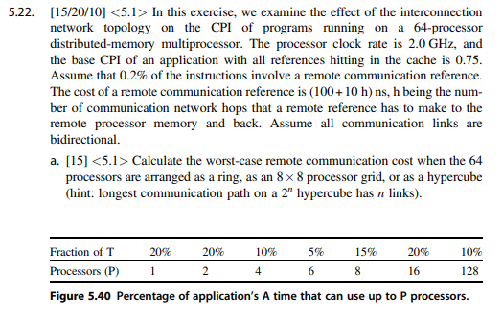
Ring:
Maximum hops: h=32 (half of 64)
Remote reference cost: 100+ 32*10= 420ns

8x8 Processor Grid:
Maximum hops: h=8+8−2=14
Remote reference cost: 100+14*10=240ns

Hypercube:
Maximum hops: $h=log_{2}(64)=6$
Remote reference cost: 100+6*10=160ns

Base CPI= 0.75

Ring:
$\frac{420 ns}{0.5 ns/clock}= 840 cycles$
$Ring CPI= 0.75+(0.002*840)=2.43$

8x8 Processor Grid:
$\frac{240 ns}{0.5 ns/clock}= 480 cycles$
$Grid CPI= 0.75+(0.002*480)=1.71$

Hypercube:
$\frac{160 ns}{0.5 ns/clock}= 480 cycles$
$Grid CPI= 0.75+(0.002*320)=1.39$

